PHASE 2: ORG SETUP & CONFIGURATION
Below are the Salesforce configurations you performed:
1. Company Profile Setup
Default org details used.
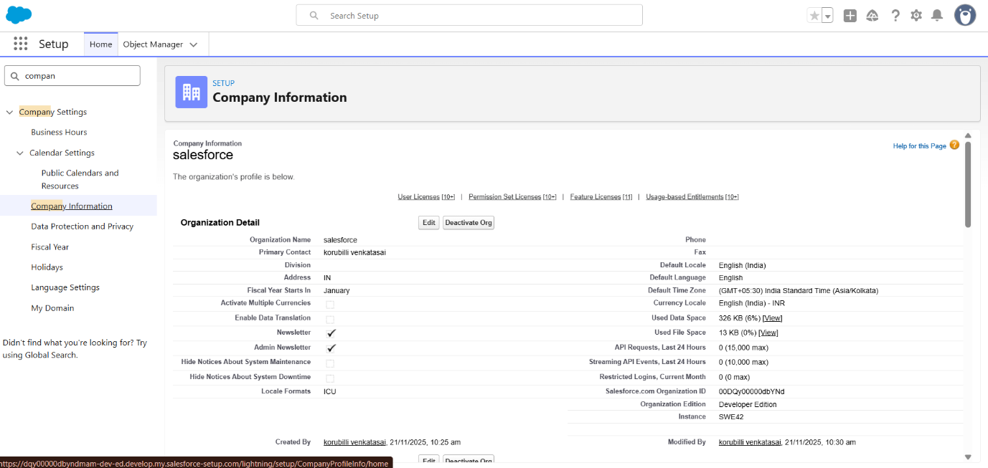

2. User Setup
Only System Administrator role needed initially.

3. Object Manager Configuration
- Navigated to Setup → Object Manager → Create New Custom Object.
- Created Salesforce Ticket object.
Custom Object Settings Configured:
- Auto Number field enabled
- Allow Reports
- Allow Search
- Allow Activities
- Track Field History
- Deployment status: Deployed

